**28/09/2021 CD SPOT 4 2019103573**

**SPOT – EXCERSISE**

**1. Consider the input expressions and identify the tokens in expression**

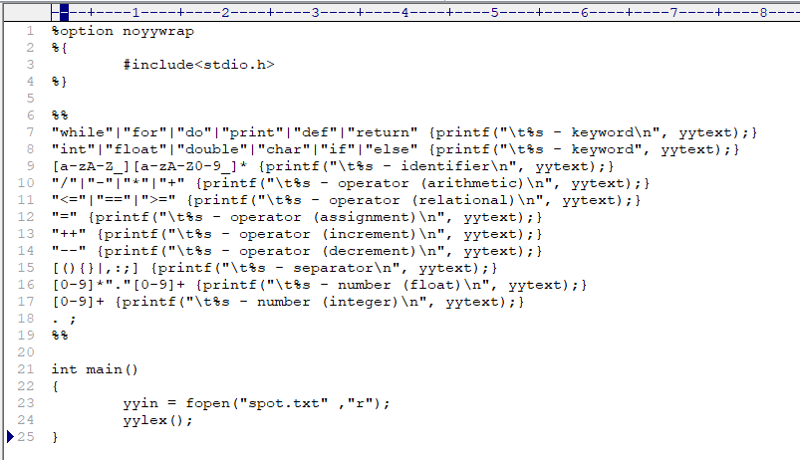**CODE :-**

**OUTPUT :-**

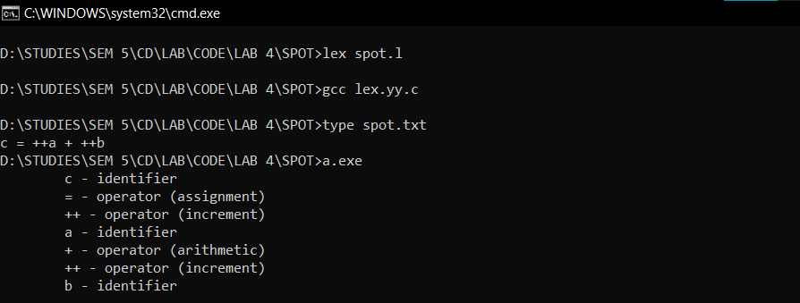**a. c = ++a + ++b**

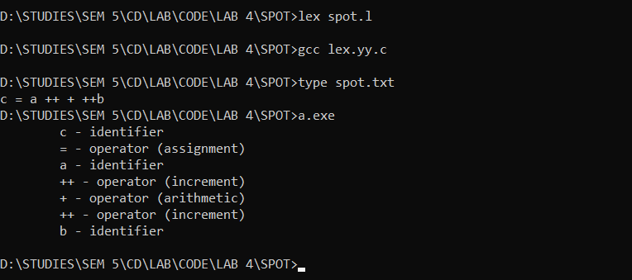**b. c = a ++ + ++b**

**2. Identify the tokens in the given input statement**

**CODE :-**

**OUTPUT :-**

**a. print ( 3 + x * 2)**

**def f(x):**

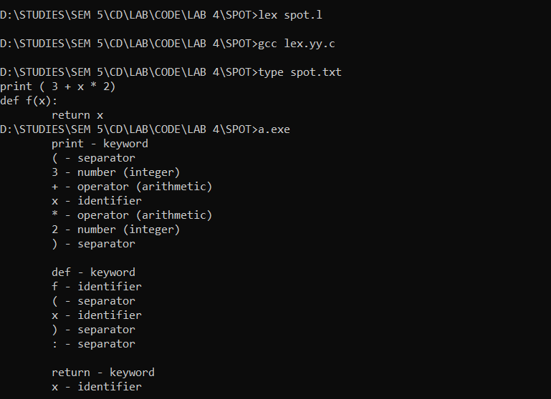 **return x**

**b. def f(x):**

**if x >= 1:**

**return x * x**

**else:**

**return x**

**print x**

